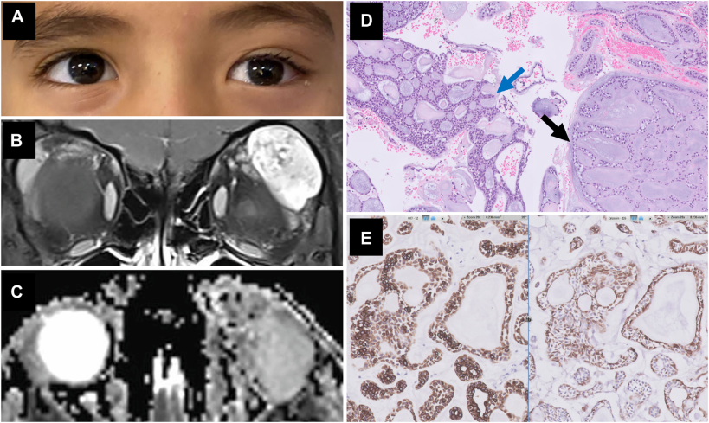

A 7-year-old boy presented with left orbital proptosis and globe dystopia (A); visual acuity and ophthalmic examination were normal.Orbital magnetic resonance imaging showed a lobular, well-defined lacrimal gland mass (B) without hypercellular features on an apparentdiffusion coefficient map (C). Surgery was conducted with a primary diagnosis of lacrimal gland pleomorphic adenoma, revealing a lobulartumor with a gelatin-like texture and no capsule. A pathological examination revealed a tumor with cribriform (D, blue arrow) andcanalicular-like (D, black arrow) characteristics, composed of inner ductal and outer myoepithelial cells. On immunostains, cytokeratin 7highlighted all the cells (E, left), and calponin highlighted myoepithelial components (E, right). fluorescent in situ hybridization resultsshowe. Based on the provided images and clinical description please make an ophthalmic diagnosis for this patient. And output the diagnostic conclusions only.

**Cribriform adenoma of the lacrimal gland**